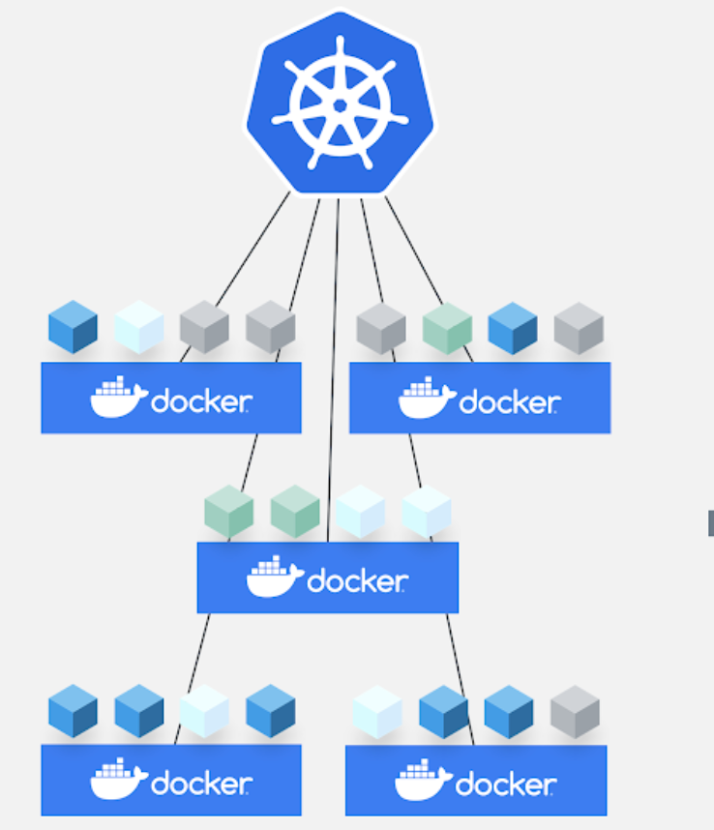

Core Concepts

Kubernetes Architecture

Master Node initialisation

Worker Nodes initialization - Worker1 & 2

Basic commands of Kubernetes

# Kubernetes Architecture

Master

API Server

Scheduler

Controller Manager

Cloud Controller Manager(CCM)

Etcd

Worker

Kubelet <-> Dockerd

Kube-proxy

Pods - Containers - App running

Operator - Access API-Server for k8s calls - Create, Update, Read, Delete resources

K8s client - UI, API, CLI - kubectl

User - App users - Access App deployed in k8s

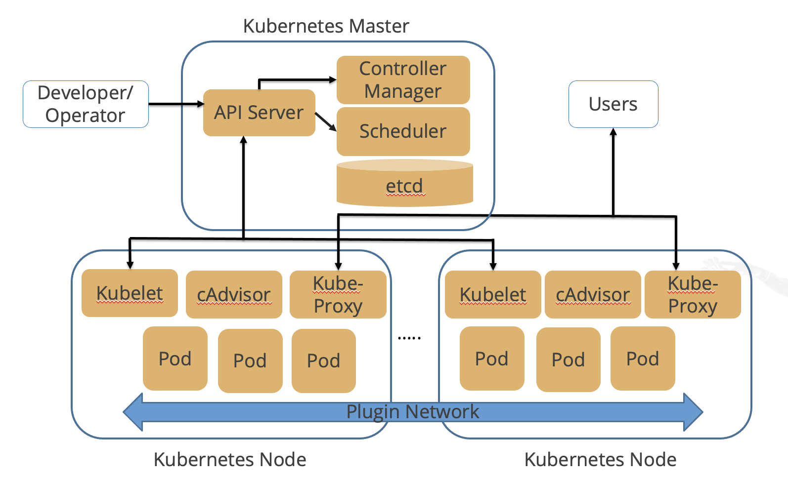

Node View - Many sizes of pods deployed

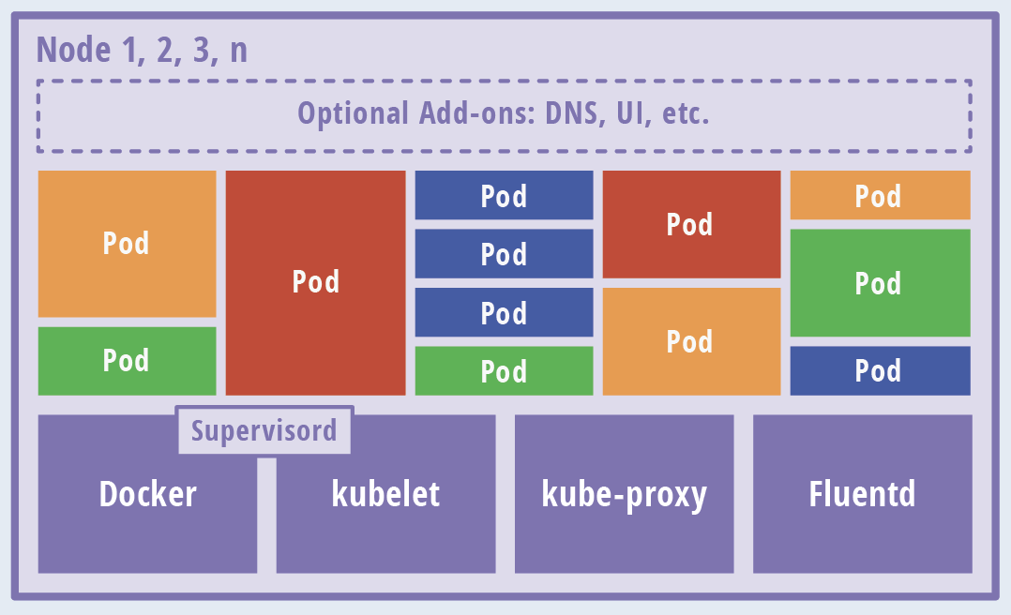

# 

# Set Hostname

Master Node:

**sudo hostnamectl set-hostname master.example.com**

**exec bash**

Worker1 Node:

**sudo hostnamectl set-hostname worker-node-1.example.com**

**exec bash**

Worker2 Node:

**sudo hostnamectl set-hostname worker-node-2.example.com**

**exec bash**

# Docker Configuration - Master, Worker1, Worker2

**cat <<EOF | sudo tee /etc/docker/daemon.json**

**{**

**"exec-opts": ["native.cgroupdriver=systemd"],**

**"log-driver": "json-file",**

**"log-opts": {**

**"max-size": "100m"**

**},**

**"storage-driver": "overlay2"**

**}**

**EOF**

**—------------------------------------------------------------**

**sudo systemctl enable docker**

**sudo systemctl daemon-reload**

**sudo systemctl restart docker**

**sudo swapoff -a**

Do the above steps in Master, Worker1 and Worker2 nodes

# Master Node initialisation

sudo kubeadm init

* TODO: Copy kubeadm join command

mkdir -p $HOME/.kube

sudo cp -i /etc/kubernetes/admin.conf $HOME/.kube/config

sudo chown $(id -u):$(id -g) $HOME/.kube/config

cat ~/.kube/config

Install Container Network Interface (**CNI**)

kubectl apply -f https://raw.githubusercontent.com/projectcalico/calico/v3.25.0/manifests/calico.yaml

Verification:

kubectl get nodes

NAME STATUS ROLES AGE VERSION

master.example.com Ready control-plane,master 64m v1.23.4

# Worker Nodes initialization - Worker1 & 2

**DONT COPY AND PASTE:**

**sudo** kubeadm join 172.31.49.128:6443 --token 6v6z4m.qpbdqgshqgbzbz7y \

--discovery-token-ca-cert-hash sha256:2f7a26f4dfc6ba079c6153ac4ef1741c3b966843177432b0ddd707f62062e70a

**Note:** In case you need to find your unique token, run the command **sudo kubeadm token create --print-join-command**

labsuser@master:~$ kubectl get nodes

NAME STATUS ROLES AGE VERSION

master Ready control-plane,master 75m v1.23.4

worker-node-1.example.com Ready <none> 72s v1.23.4

worker-node-2.example.com Ready <none> 52s v1.23.4